**10. ReactJS-HOL**

**Theory**

* JSX stands for JavaScript XML. It is a syntax extension for JavaScript used in React to describe what the UI should look like. JSX allows developers to write HTML-like code inside JavaScript, making it easier to create and visualize React components. Although browsers do not understand JSX directly, tools like Babel compile JSX into regular JavaScript that browsers can execute.
* ECMAScript, often abbreviated as ES, is the standardized version of JavaScript maintained by ECMA International. It defines the rules, features, and updates for the JavaScript language. Versions like ES6 introduced important features such as let, const, arrow functions, classes, promises, and more, which are now widely used in modern JavaScript development.
* The React.createElement() method is used by React to create virtual DOM elements. It takes three arguments: the type of element (like 'div'), properties (or props), and children (text, other elements, or components). For example, React.createElement('h1', null, 'Hello') creates a heading element with the text "Hello". JSX is syntactic sugar over this method, making the code cleaner and easier to write.
* To create React nodes with JSX, you simply write HTML-like tags within a JavaScript function or component. For example, const element = <h1>Hello, world!</h1>; creates a React node that can be rendered to the DOM. This is internally transformed into React.createElement() calls during compilation.
* To render JSX to the DOM, you use the ReactDOM.render() method. This method takes a JSX element and a DOM container as arguments. For example, ReactDOM.render(<App />, document.getElementById('root')); renders the App component into the HTML element with the id of "root".
* You can use JavaScript expressions inside JSX by wrapping them in curly braces {}. These expressions can include variables, function calls, mathematical operations, and more. For example, <p>{5 + 5}</p> will display the result "10" inside the paragraph.
* Inline CSS in JSX is applied using a style attribute that takes a JavaScript object instead of a string. Each CSS property name is written in camelCase, and the values are provided as strings or variables. For example, <div style={{ color: 'red', fontSize: '20px' }}>Hello</div> applies the styles directly to the div element.

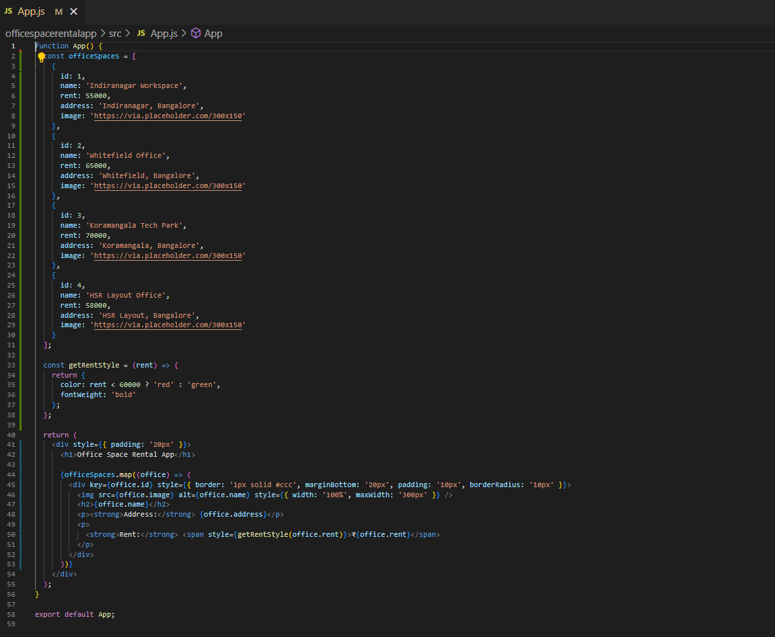

**Output**

